**Creating User_CEO (Role is already made by me)**

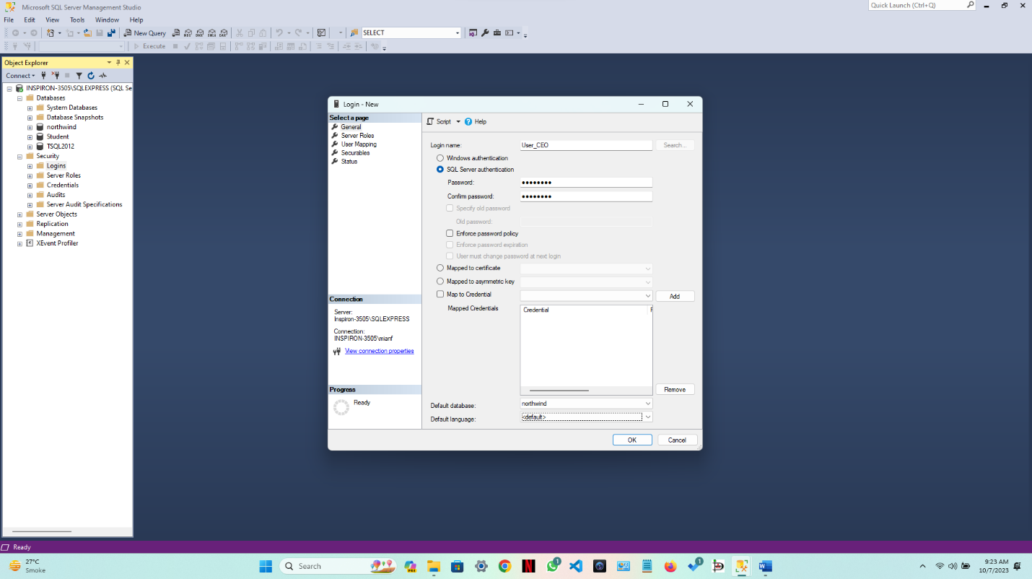

**

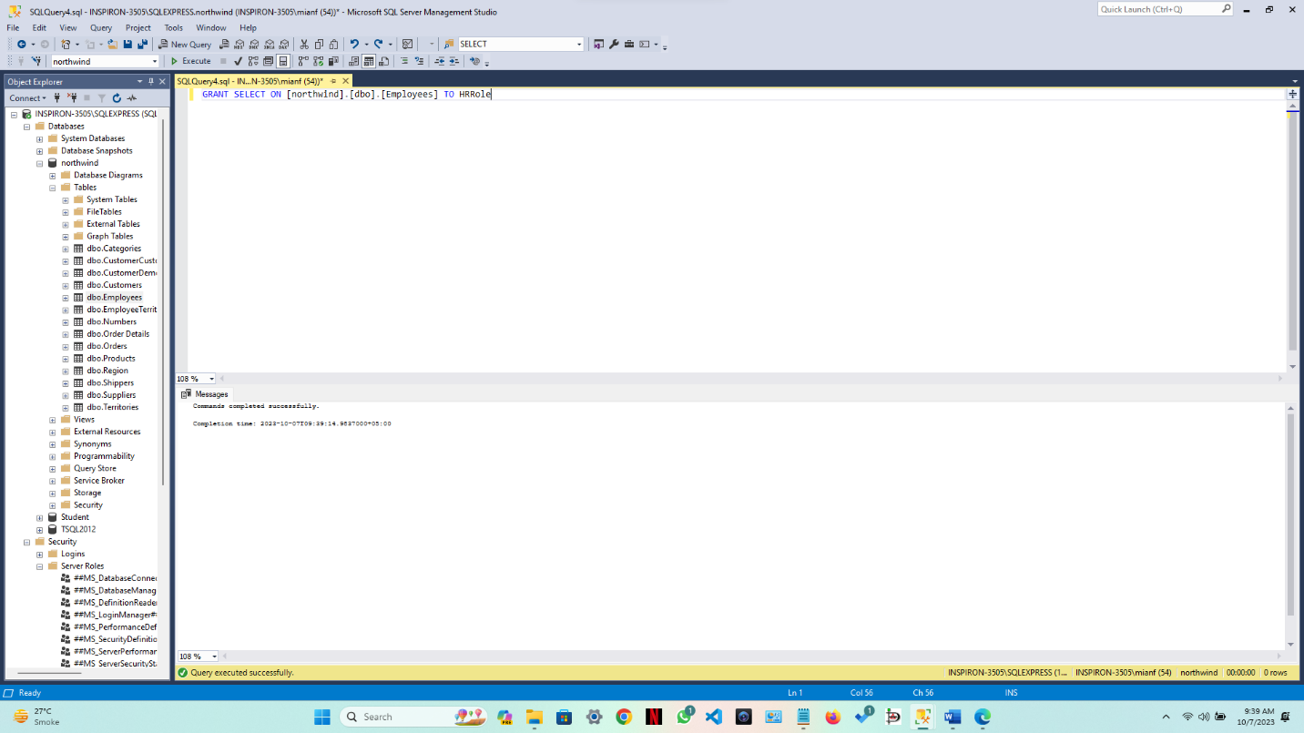

**

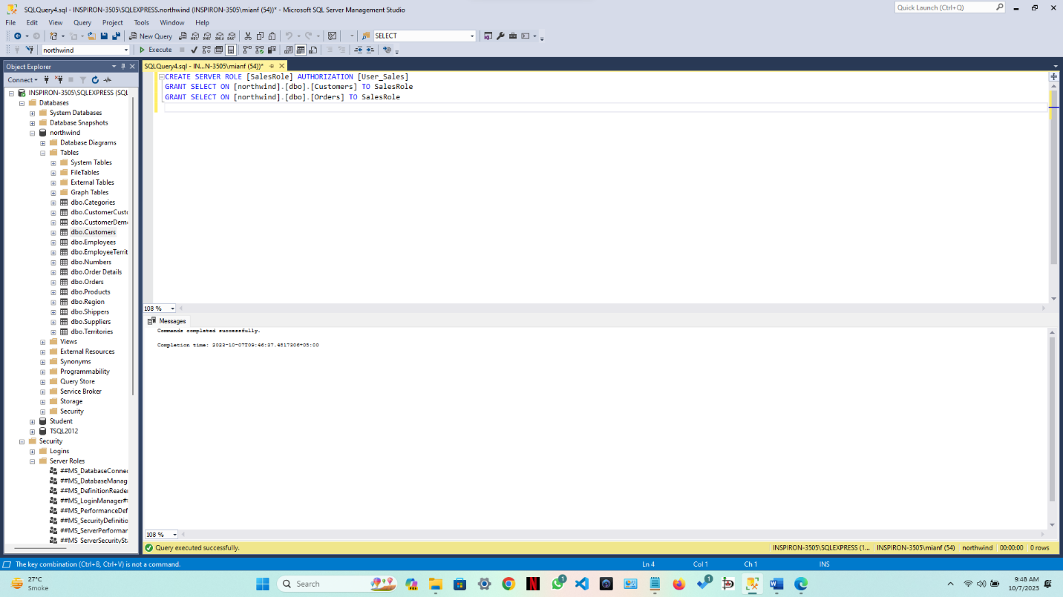

**All Roles and Logins**

Testing App

Login Form

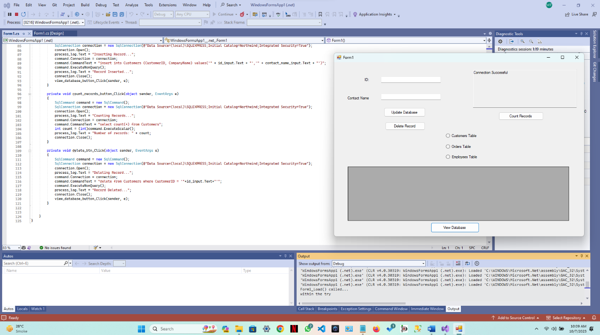

The app is working as per requirements.